**Swiss-RE Site-to-Site VPN Request**

**Step-1: -**

**Fig-1**

* Click on the **Create Transit gateway**

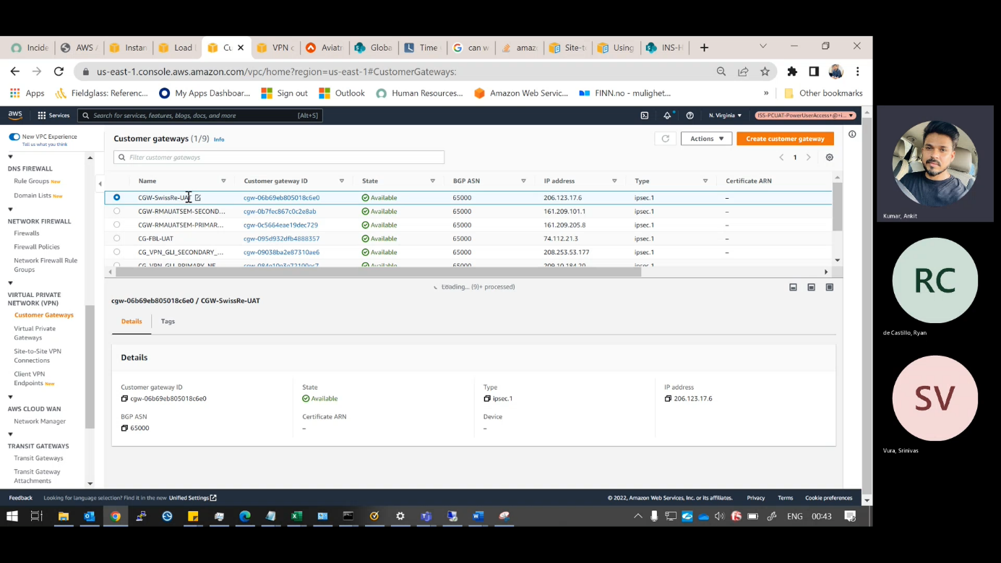

**Fig-2**

* Create the **transit gate way in the name of VPN** & give the description as same.
* Click on the **Create transit gate way**.

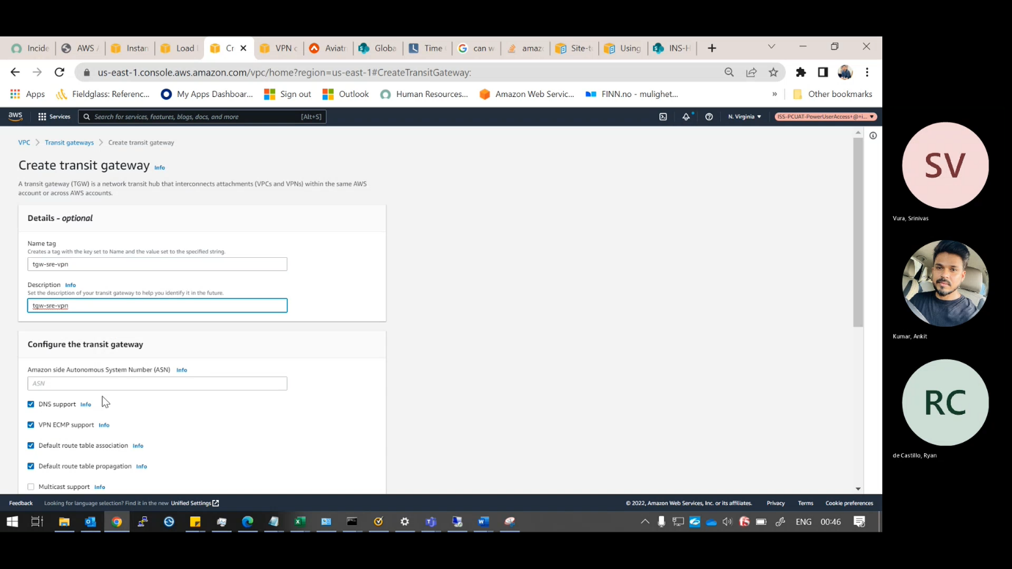

**Step-2: -**

**Fig-3**

* Click on the **Create Transit gateway Attachment**.

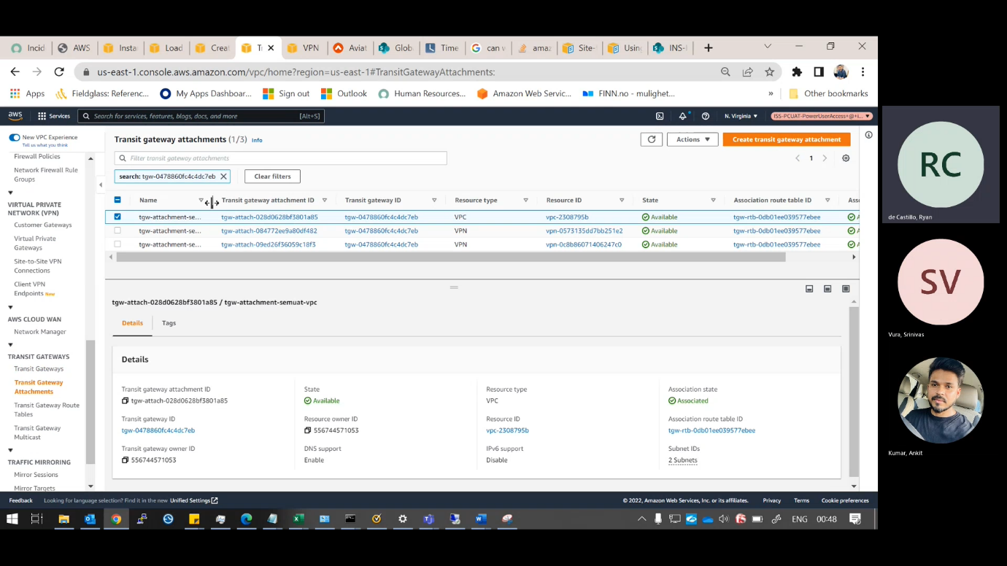

**Fig-4**

* Create **Transit gateway Attachment in the name of VPN**.
* select the transit gate way which we were created before.
* Attachment type is “**VPC”.**

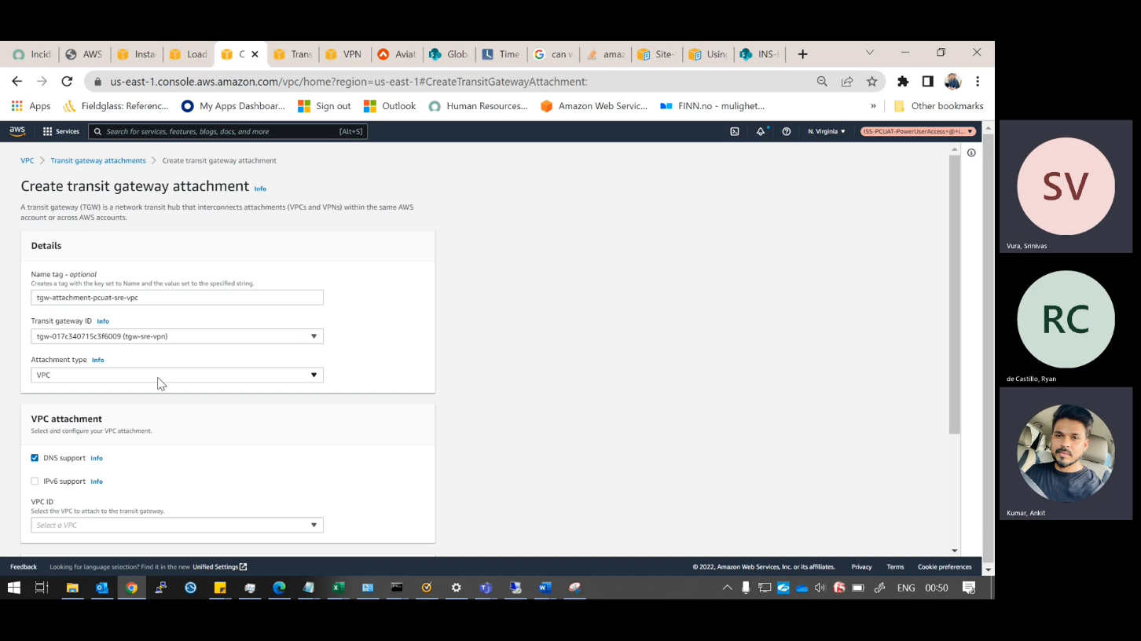

**Fig-5**

* Choose the **VPC** and choose the **private subnets**.
* Click on the Create **Transit gateway Attachment**.

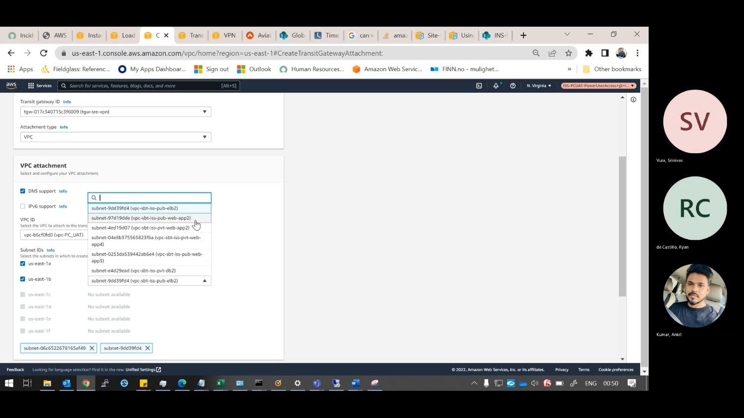

**Step-3: -**

**Fig-6**

* Go to the site-to-site VPN Connection.
* Click on the create VPN Connection.

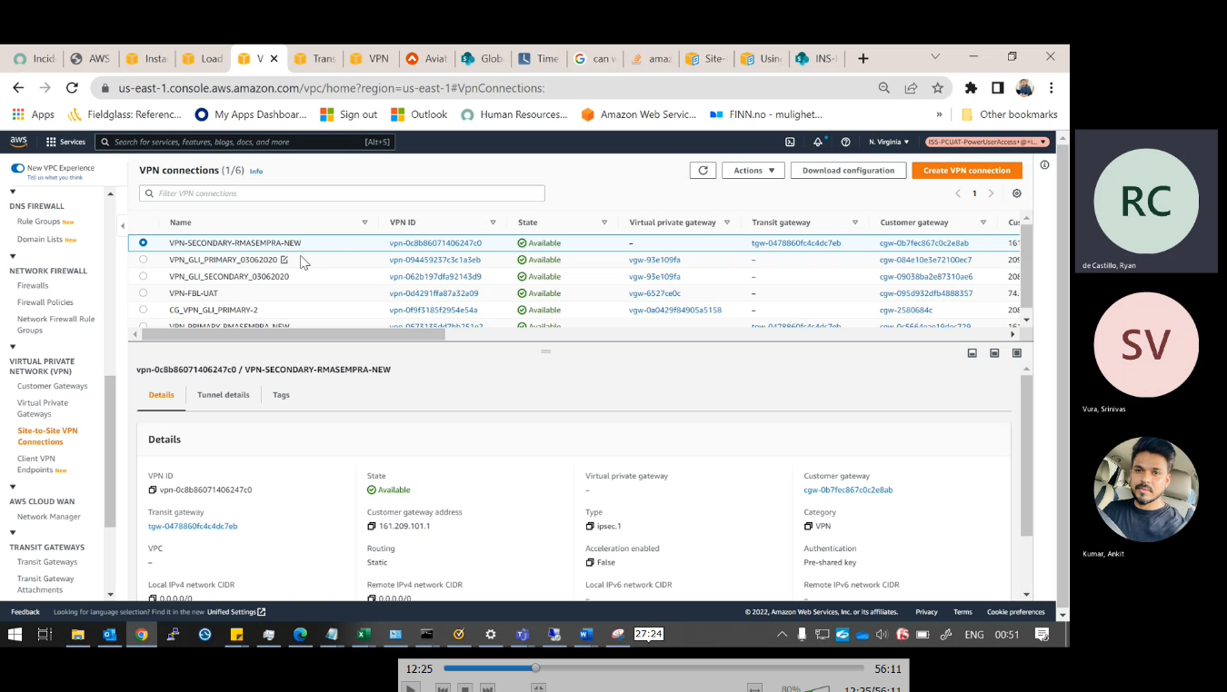

**Fig-7**

* Create the **VPN connection in the name of Swiss-RE-UAT**.
* Select the **Transit gateway** and corresponding ID.
* Select the Customer gateway ID if you are created before select the existing one or else select the new one, here I created previously so **I selected existing one and its ID also**.
* Routing option should be “**Static”.**

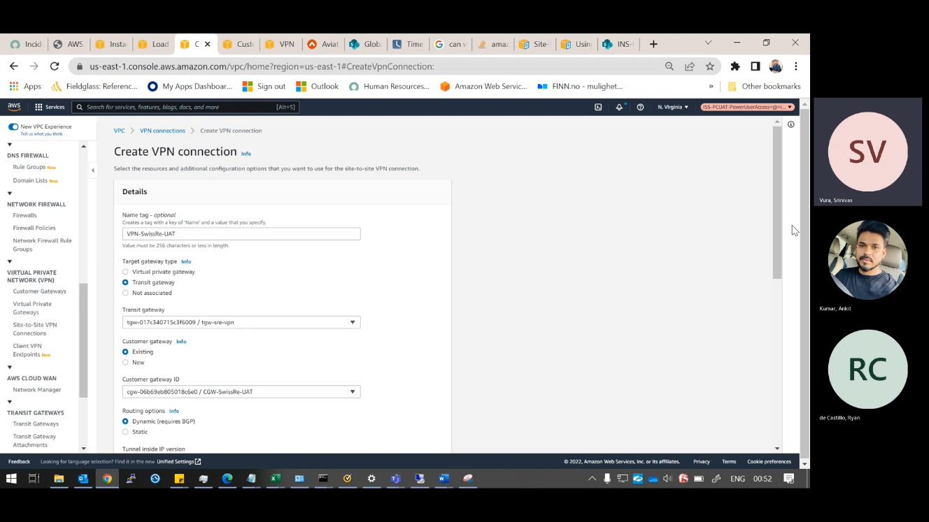

**Fig-8**

* Here they have given the tunnel details, so we need to change according to their requirement.

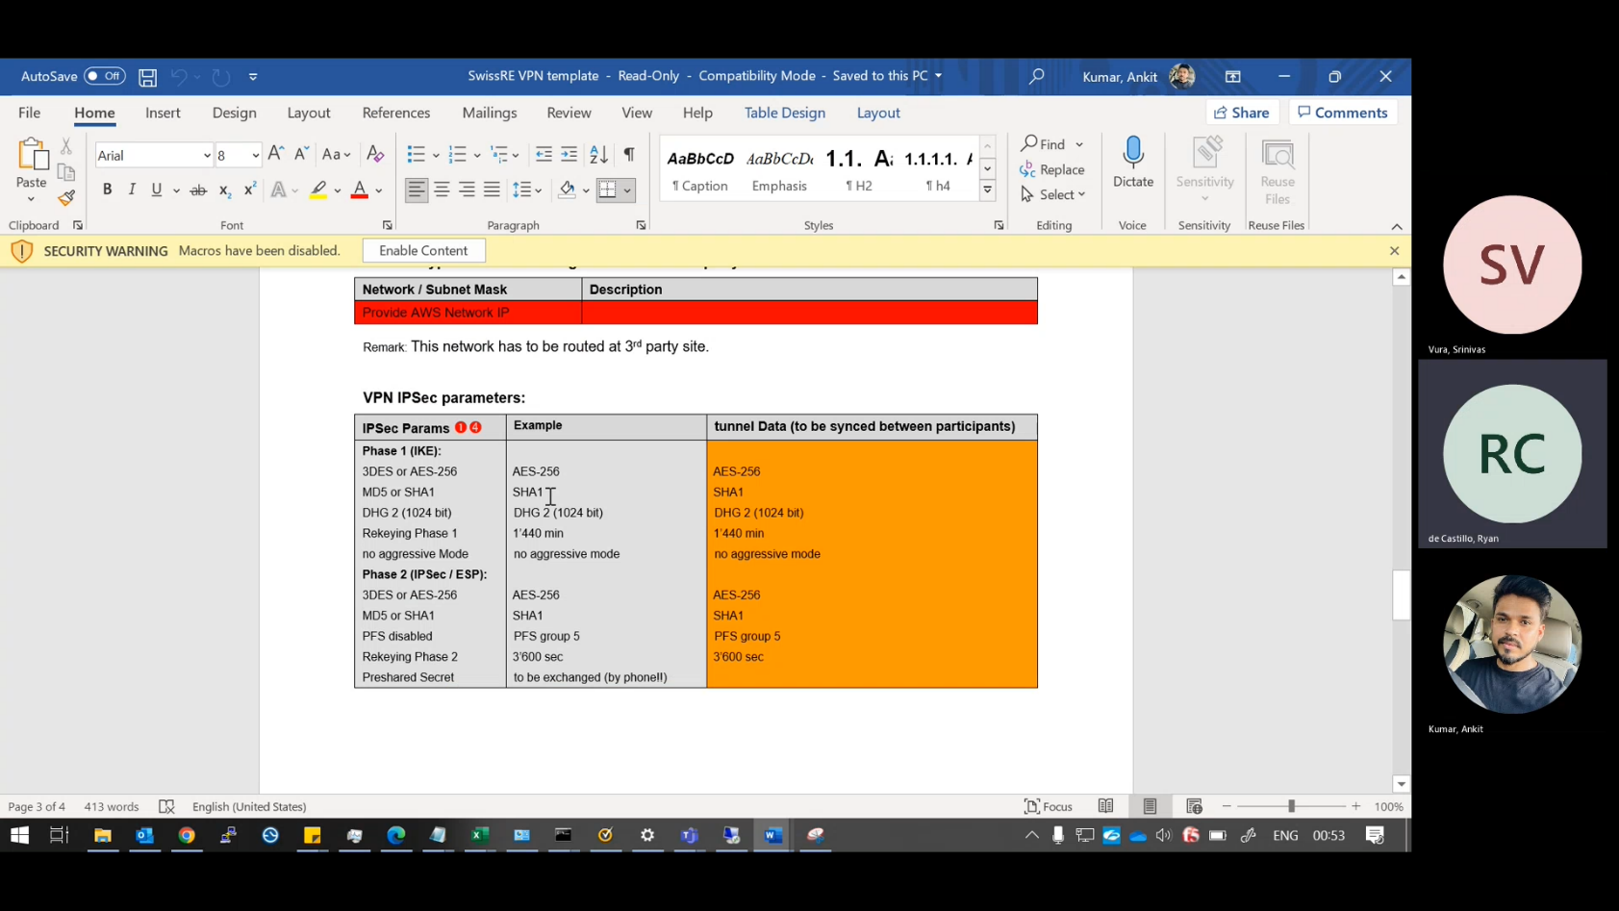

**Fig-9**

* Change **the Tunnel-1 & 2 options according to the built form** they have given.
* Then click on the **Create VPN Connection**.

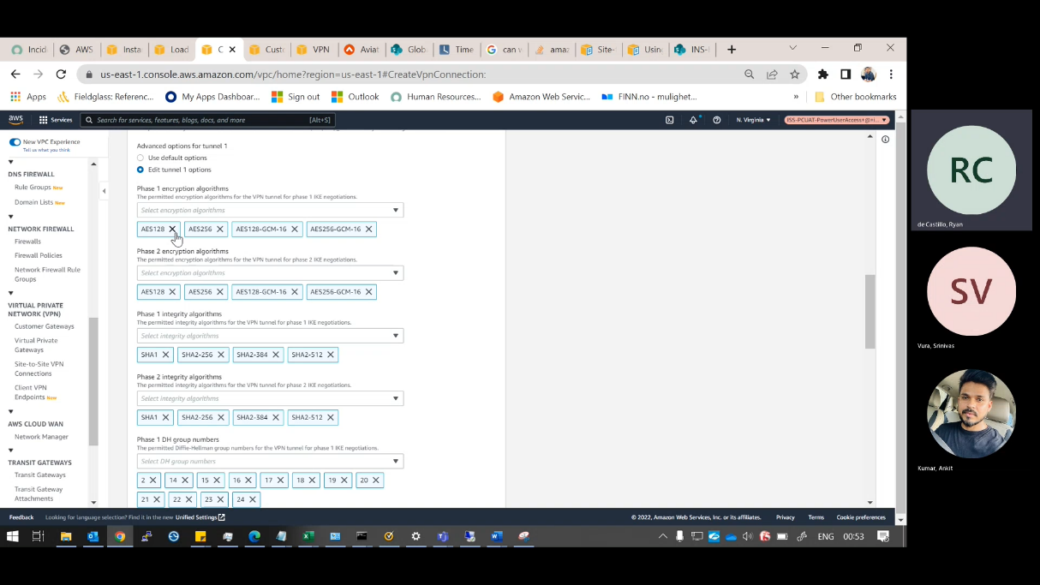

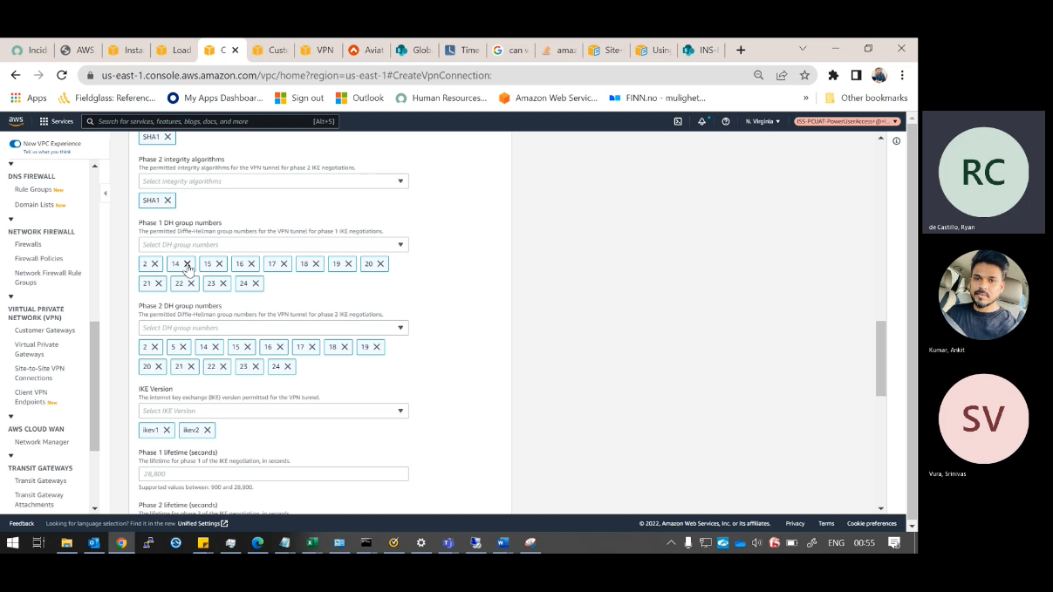

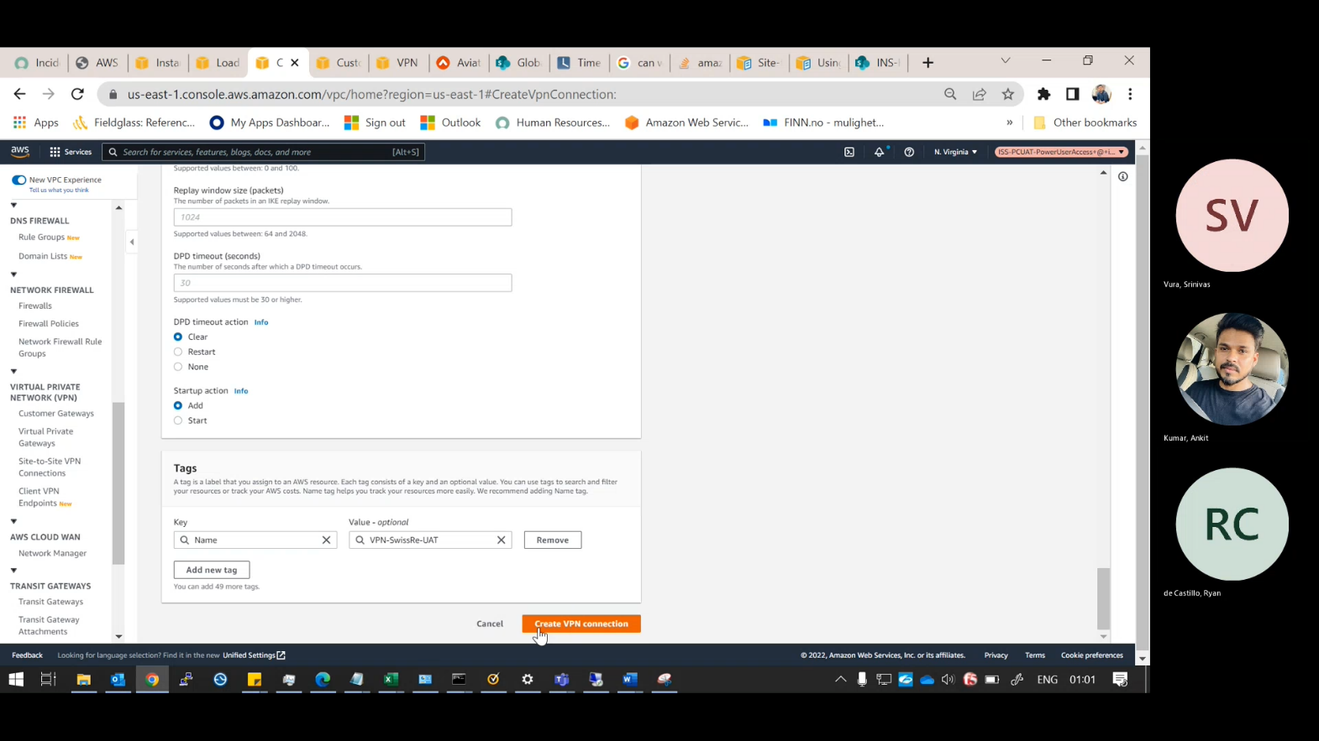

**Fig-10**

* The VPN connection which we created is **directly attached to the Transit gateway** so give that **VPN connection with a name**.

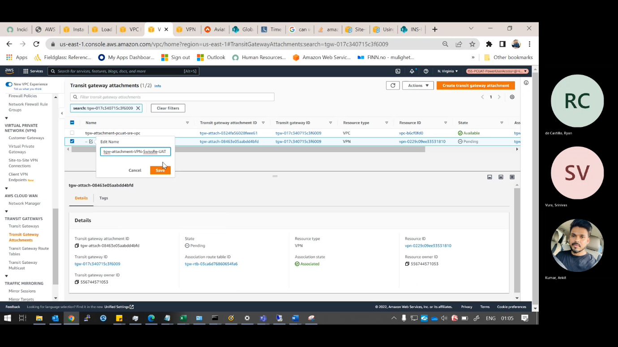

**Step-4: -**

**Fig-11**

* Go to the **Transit gateway Route Tables**.
* Go to the Routes & click on the **“Create static Route”**

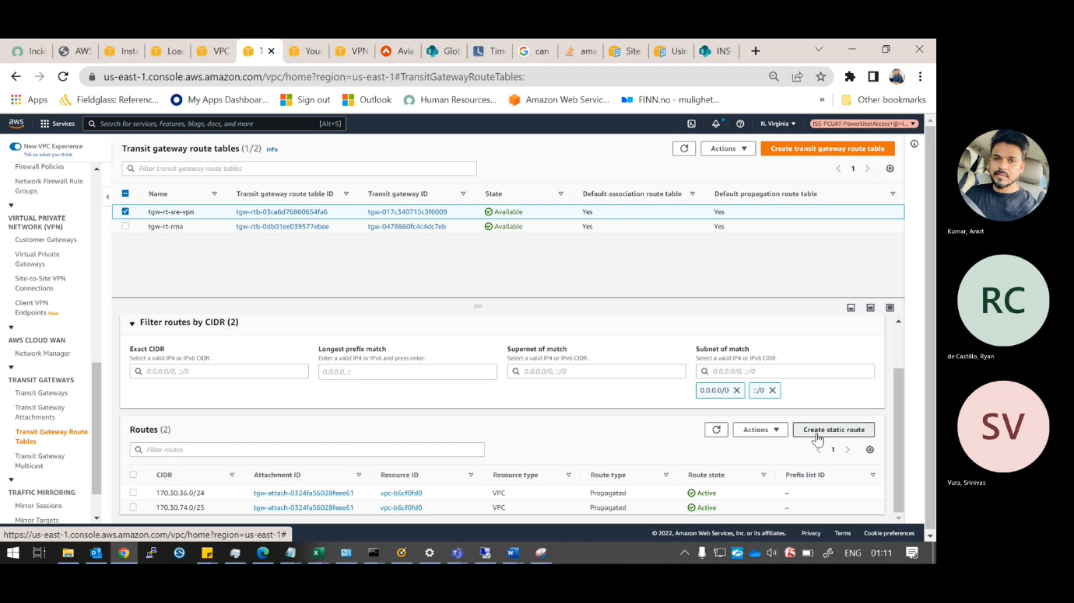

**Fig-12**

* Give the CIDR which is given in the built form that is **source IP**.
* Select the VPN attachment & click on the **“Create Static Route Table”**

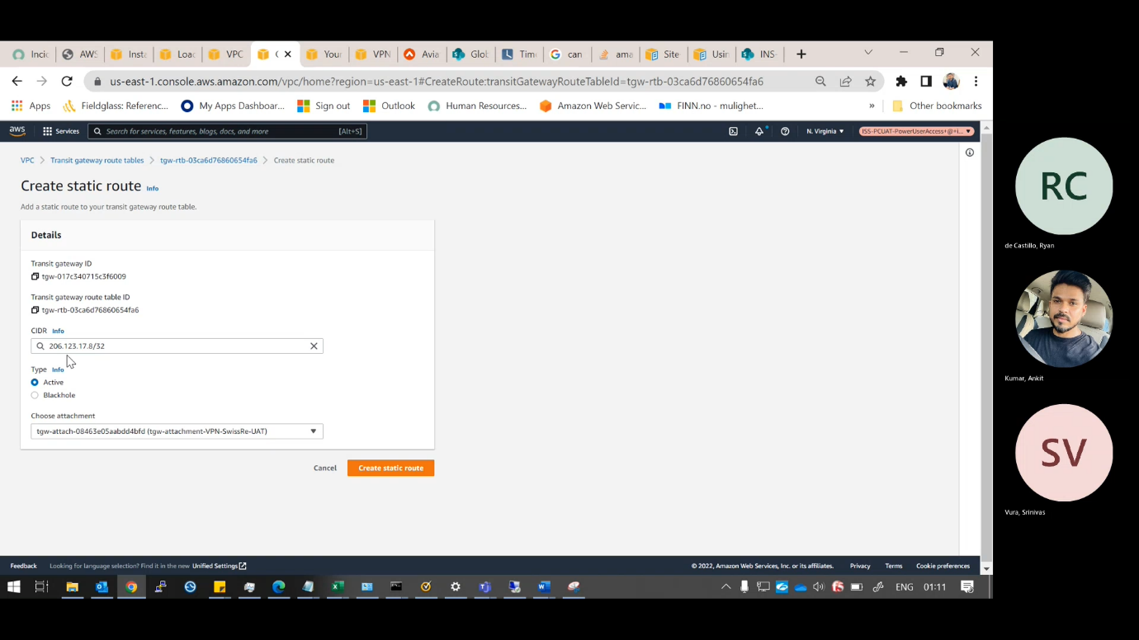

**Step-5: -**

**Fig-13**

* Go to the **subnet of the VPC**, then go to the **Subnet Route tables**.
* Allow the traffic to the **Transit gateway** and click on the save changes.

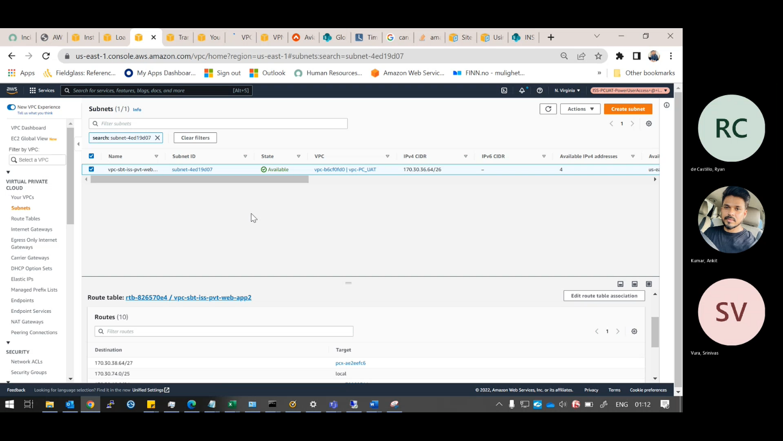

**Fig-14**

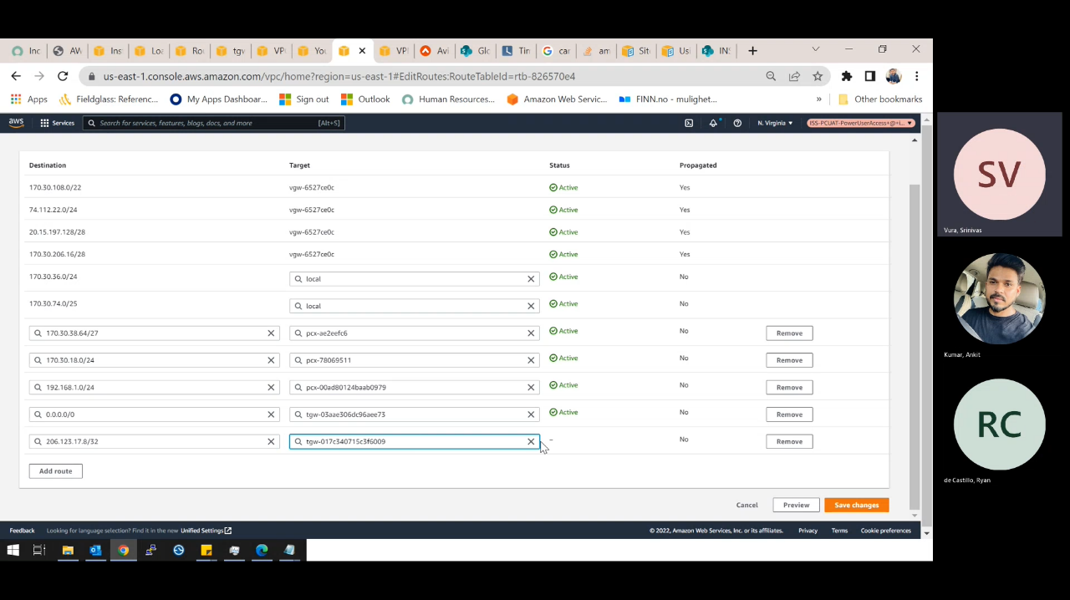

**Step-7: -**

* We need to **update the security groups and allow the ports** which we are given in the Description **individual for the Servers**.

**Fig-15**

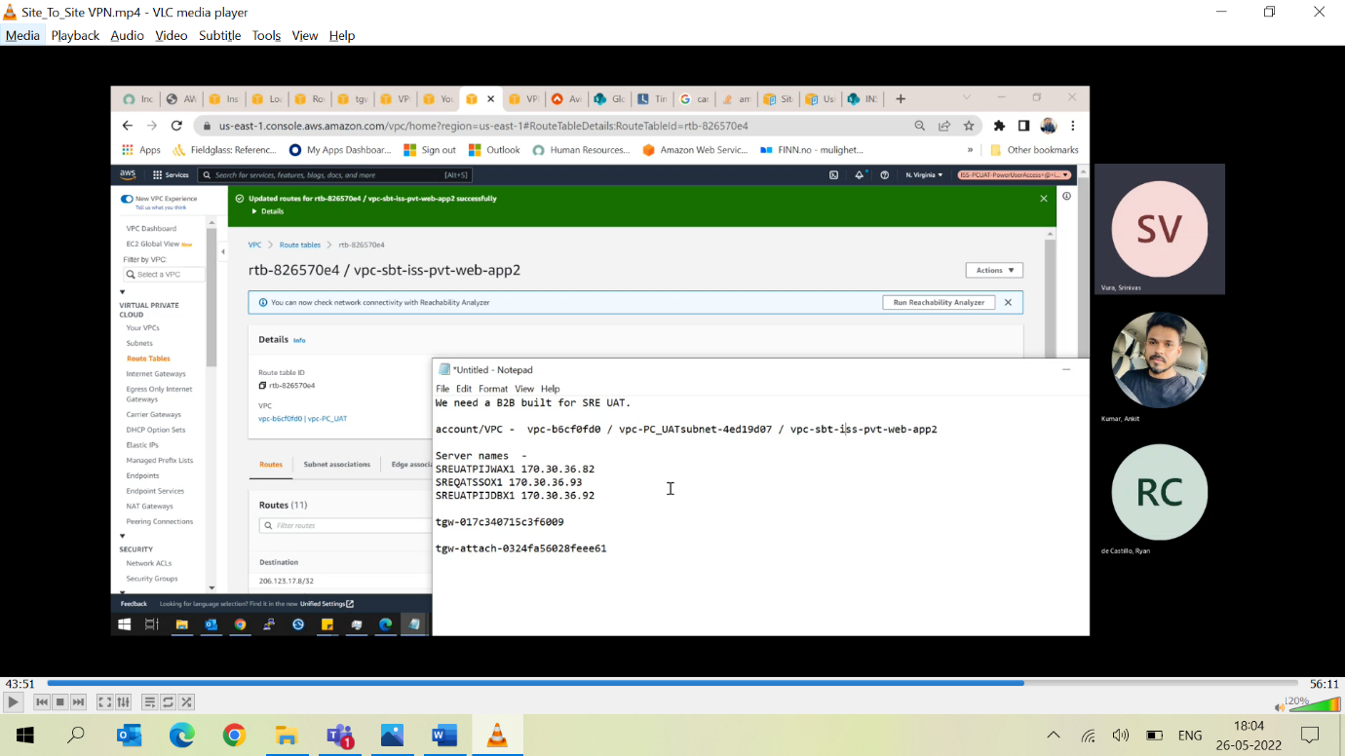

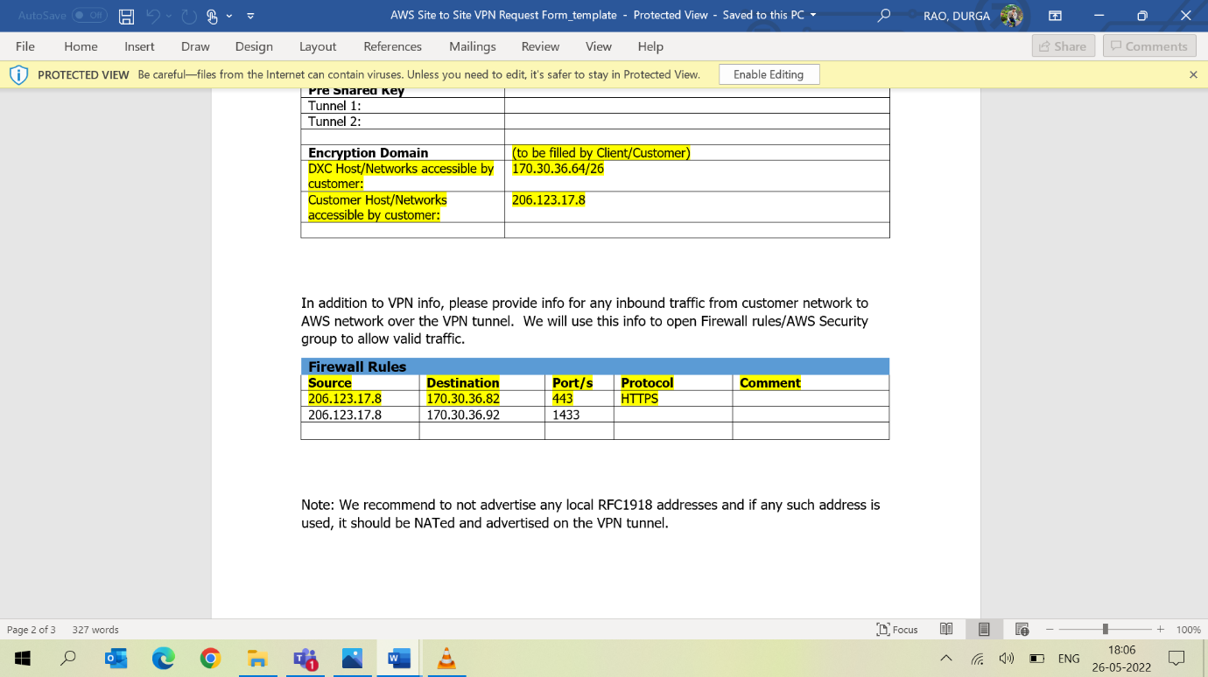

**Fig-16**

* Go to the **Security Group of each server** and **edit inbound rules and allow the ports** according to the Requirement then save the Rules.

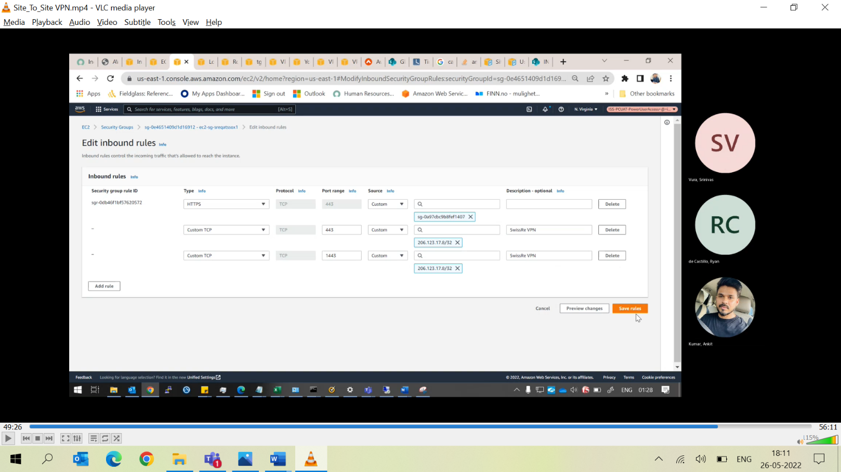

**Step-8: -**

**Fig-17**

* Go to the site-to-site VPN, Select the VPN which we are created.
* Click on the **Download Configuration**.

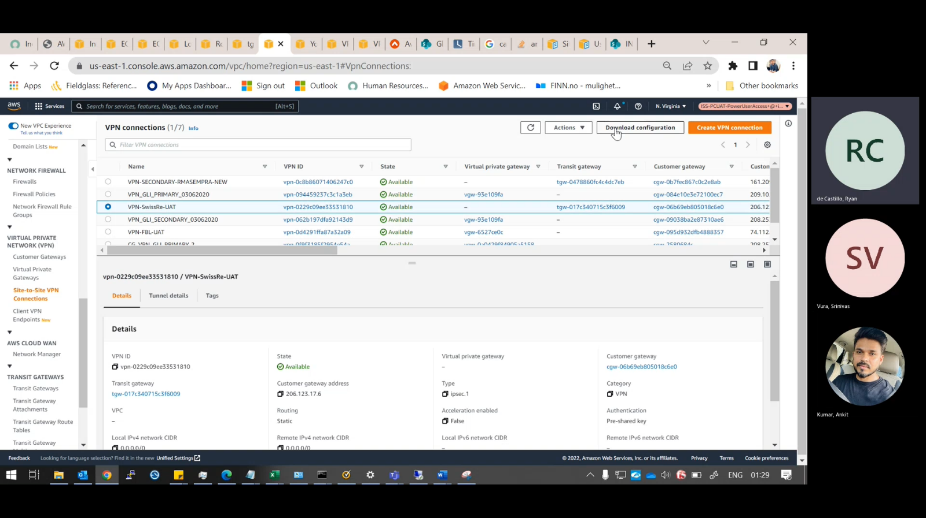

**Fig-18**

* Here the download configuration has specific requirements choose according to this details.

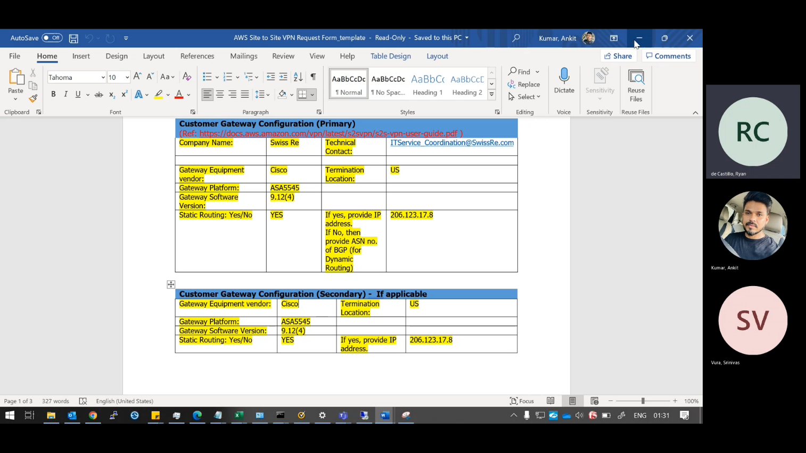

**Fig-19**

* After choosing all the requirements Click on the **Download option**.
* **Configuration file contains pre shared key provided by the Amazon and all the details they want to connect to the created VPN**.

